Mastering The Art of Searching The Web

Searching The Web With Google
Google Search – The Essentials

- We all know that web search can be a remarkable research tool – but also know that we can sometimes find ourselves unnecessarily wading through untargeted search results.
- This quick tutorial will help you teach how to search the web more effectively.
- Google Presentation: "Start Your Engine"
- YouTube Video: "How Search Works by Matt Cutts"
- YouTube Video: "Matt Cutts Discusses Snippets"
- 15 Second Search Tips Videos

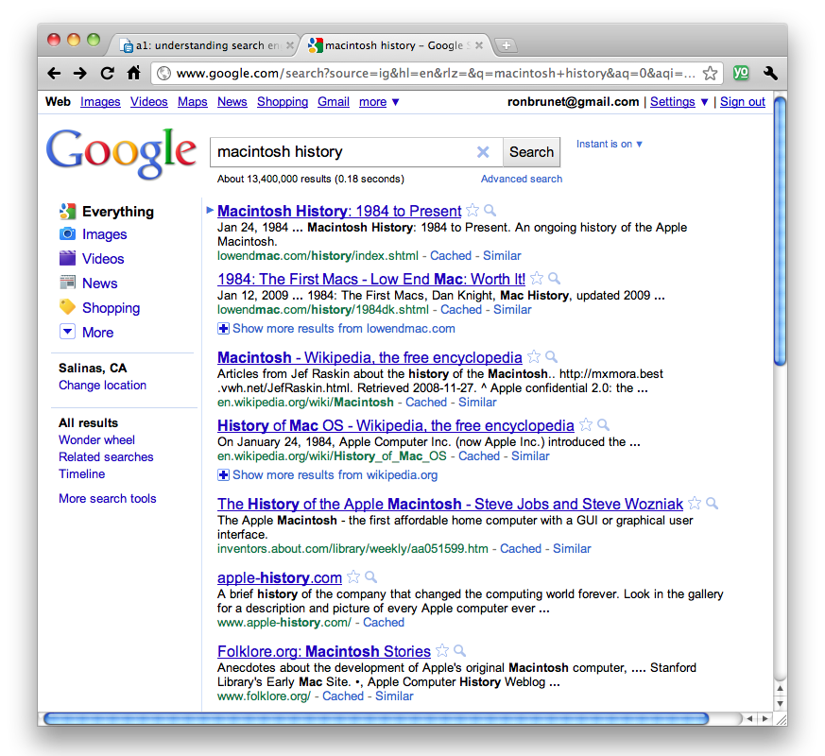
Search Google Now
Using the Advanced Search Function

The Advanced Search function allows you to refine and narrow your Google searches

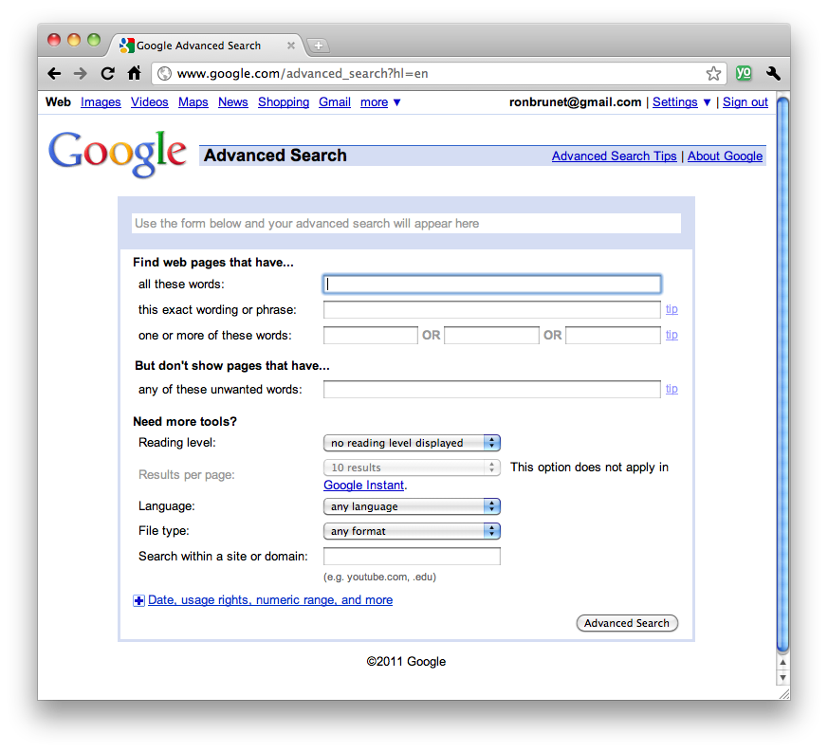

Advanced Search Tips

Go to Google Advanced Search
- Don't miss File Type and Usage Rights.
- Don't forget to learn the Google Operators like Define: and others.
- Don't miss some of Google’s more popular search features.

Improve Your Search Experience

In addition to providing easy access to billions of web pages, Google has many special features to help you to find exactly what you're looking for.

Check out some of Google’s most popular features.

Compare your search results in a spreadsheet.
Specialized Search

- Google Scholar - Search scholarly sources
- http://scholar.google.com

- Google Books - Search full textbooks
- http://books.google.com

- Google News - Search worldwide news sources
- http://news.google.com

- Google Blog Search - Search the latest scoop
- http://blogsearch.google.com

- Even More - Explore other specialized searches
- www.google.com/options/

Google Labs

- Google Labs - A showcase of new tools!
- http://labs.google.com

- Google Trends - See global search trends!
- http://www.google.com/trends/

- Google Sets - Create lists from a few examples!
- http://labs.google.com/sets

- Experimental Search - Check out Google’s latest!
- http://www.google.com/experimental/

YoLink Download the App

Search inside links
- Watch how to search inside links for key terms and concepts.
- http://www.youtube.com/watch?v=J0VnXFudVnQ

From search to find
- Watch how to search text for multiple terms and concepts.
- http://www.youtube.com/watch?v=LOu05Ue91vA

Share with Google docs
- Watch how to share information instantly with Google Docs.
- http://www.youtube.com/v/pl5W1TE0mPA

